Station #1
Bird-Ae’o (Hawaiian Stilt)
Food Source-Grubs buried in marshy soil (flour, water and dirt)
Tools-Chopsticks, Turkey Baster, Tweezer

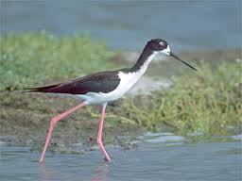
Challenge #1 –You have been given grubs to represent worms as your food source. You have also been given sample beaks:
- Chopsticks
- Turkey Baster
- Tweezer
Your challenge is to obtain as many fishing worms as you can that are buried in the ‘soil’ within 30 seconds. Put your food in your stomach (plastic cup). Repeat each trial 3 times and record the amount of food after each trial.

