Station #4
Bird-Akepa
Food Source-Rice spread out on a tray (to represent insects)
Tools- Tweezers, Clothespins, Test tube holder

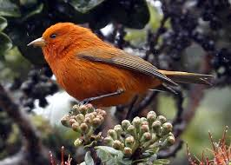

Challenge #4- You have been given rice (to represent insects) as your food source.
You have also been given sample beaks:
1.Tweezer
2. Clothespins
3. Test Tube holder
Your challenge is to use each beak and transfer as many pieces of rice to your stomach (plastic cup) in 30 seconds. Repeat each trail 3 times an record the amount of food after each trial on your worksheet

