Station #3
Bird-I’iwi
Food Source-Colored water (nectar)
Tools-Medicine dropper, Straw, Pipette

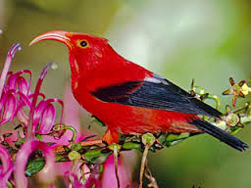
Challenge #3 –You have been colored water to represent nectar as your food source. You have also been given sample beaks:
- Medicine Dropper
- Straw (use finger to keep liquid in the straw, NOT your mouth)
- Pipette
Your challenge is to use each beak to see how much water you can transfer to your stomach (beaker) in 30 seconds. You will then measure the amount in the graduated cylinders. Repeat each trial 3 times and record the amount of liquid in milliliters after each trial.

