Station #2
Bird-Palila
Food Source-Sunflower Seeds scattered in a tray
Tools-Chopsticks, Clothespin, Tweezer
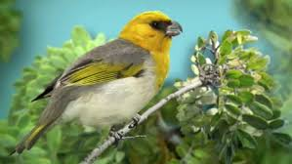

Challenge #2 –You have been sunflower seeds to represent seeds as your food source. You have also been given sample beaks:
- Chopsticks
- Clothespin
- Tweezer
Your challenge is to use each beak to CRACK the shell and remove the seed inside within 30 seconds. Put your SHELLED seeds in your stomach (plastic cup). Repeat each trial 3 times and record the amount of food after each trial.

